**Manar Kbyeh 3MT Logboek Proof of Concept**

*15/12/2017*

13:00 21:00

Fingerprint scanner met de arduino proberen te verbinden (gelukt)

http://gsxbr.net/homunculo/?p=319

<https://github.com/adafruit/Adafruit-Fingerprint-Sensor-Library/tree/master/examples/enroll>

<https://www.youtube.com/watch?v=1diFaa5OsFg>

https://www.youtube.com/watch?v=nxjLx5RdaSQ

*16/12/2017 – 20-12-2017*

17:00 21:00

Verbinding proberen maken met de seriële poort met PHP (niet gelukt omdat hij de data uit de serial port niet kan lezen)

<https://github.com/lepiaf/serialport>

<https://github.com/manarkbyeh/proof-of-concept/tree/master/fingerafdruk>

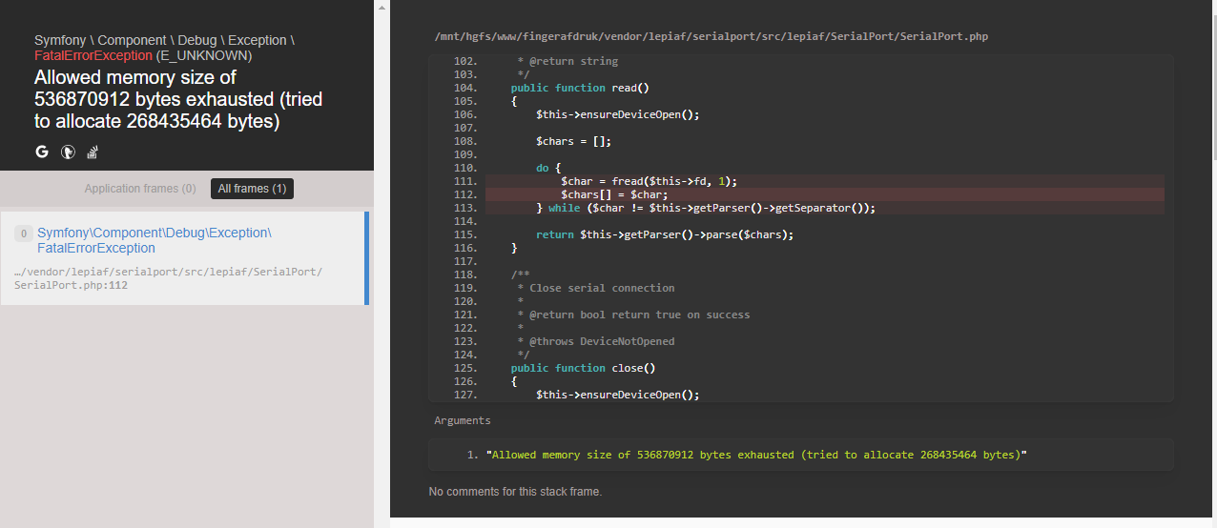

*25/12/2017*

13:00 – 21:00

Naar beste manier gezocht om Arduino met serialport te verbinden <https://www.google.be/search?ei=FZZbWufFBcTTwALd8q_QDg&q=the+best+way+to+connect+arduino+with+serialport&oq=the+best+way+to+connect+arduino+with+serialport&gs_l=psy-ab.3...65543.75941.0.76767.29.25.2.0.0.0.143.1937.23j2.25.0....0...1c.1.64.psy-ab..5.17.1331...33i160k1j33i21k1j35i39k1.0.iTUWMqJ438c>

Helpende bron gevonden:

<https://www.npmjs.com/package/serialport>

Serialport proberen installeren:

https://www.youtube.com/watch?v=DNeHg4eIB6w

https://www.npmjs.com/package/serialport

Probleem met installatie serialport:

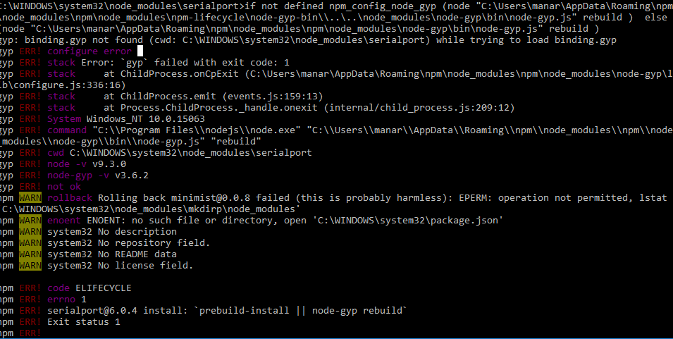

<https://github.com/node-serialport/node-serialport/issues/288>

<https://github.com/node-serialport/node-serialport>

<https://www.npmjs.com/package/serialport>

<https://www.youtube.com/watch?v=rhagmAv35Kk>

<https://www.youtube.com/watch?v=LNtmLapUSzw>

<https://stackoverflow.com/questions/20549151/how-to-read-serial-port-data-from-javascript>

<https://www.arduinoslovakia.eu/blog/2017/5/komunikacia-medzi-arduinom-a-nodejs-pomocou-serioveho-portu?lang=en>

<http://danialk.github.io/blog/2014/04/12/arduino-and-nodejs-communication-with-serial-ports/>

<http://www.barryvandam.com/node-js-communicating-with-arduino/>

<https://www.youtube.com/watch?v=_Wo5UExJ_Lk>

<https://github.com/GianlucaGuarini/nodejs-arduino-example/blob/master/server/server.js>

<https://www.youtube.com/watch?v=AhST3tTdmWk&t=1878s>

<https://www.youtube.com/watch?v=rhagmAv35Kk&list=PLmMvmcAkp42je3n5ybjVcYVDbGXKXXGD_>

*28-12-2017*

9:50 – 17:00

Geprobeerd node serialport te installeren (niet gelukt)

<https://learn.adafruit.com/adafruit-optical-fingerprint-sensor>

<https://github.com/adafruit/adafruit-io-node>

<https://create.arduino.cc/projecthub/nickthegreek82/arduino-fingerprint-sensor-tutorial-103bb4>

<http://www.jomutech.co.ke/webfingerprintmod.php>

<https://gist.github.com/jeffThompson/7d4e25bd26253c41bb2b67aca38c1099>

<https://www.hackster.io/detox/send-esp8266-data-to-your-webpage-no-at-commands-7ebfec>

<https://forum.arduino.cc/index.php?topic=470602.0>

<https://github.com/arduino-libraries/WiFi101>

<https://github.com/arduino-libraries/WiFi101/blob/master/examples/WiFiWebServer/WiFiWebServer.ino>

<https://www.arduino.cc/en/Reference/WiFi101>

<https://github.com/arduino-libraries/WiFi101/blob/master/src/WiFi101.h>

<https://www.npmjs.com/package/serialport>

<https://stackoverflow.com/questions/15126050/running-python-on-windows-for-node-js-dependencies>

<https://github.com/felixrieseberg/windows-build-tools/issues/56>

<https://github.com/nodejs/node-gyp>

<https://github.com/ecto/duino>

<https://github.com/node-serialport/node-serialport>

<https://github.com/nodejs/node-gyp/issues/762>

<https://github.com/npm/npm/issues/14543>

<https://github.com/npm/npm/pull/14568>

<https://github.com/nodejs/node-gyp/issues/1195>

<https://github.com/nodejs/node-gyp#installation>

<https://github.com/nodejs/node-gyp>

<https://blog.risingstack.com/node-js-windows-10-tutorial/>

<https://www.python.org/downloads/windows/>

<https://github.com/nodejs/node-gyp>

<https://github.com/nodejs/node-gyp/issues/1195>

<https://stackoverflow.com/questions/47574273/binding-gyp-not-found-cwd-node-modules-appium-node-modules-heapdump-while-tr>

<https://stackoverflow.com/questions/7665093/php-fopen-error-failed-to-open-stream-permission-denied>

*29-12-2017*

16:00 23:00

Geprobeerd node serialport te installeren (niet gelukt)

<https://github.com/node-serialport/node-serialport/blob/HEAD/examples/mocking.js>

<https://github.com/node-serialport/node-serialport/issues/1425>

<https://nodejs.org/en/blog/release/v8.0.0/>

<https://www.youtube.com/watch?v=BxWR0Iak2ZI>

<https://www.youtube.com/watch?v=P05QDE6HQ_w>

<https://www.youtube.com/watch?v=qzPFmxzcMHE>

<https://www.youtube.com/watch?v=L0h9vvjfar8>

<https://www.youtube.com/watch?v=3SEoI_VJEwQ>

<https://github.com/aldwinhermanudin/mshrm>

<https://github.com/aldwinhermanudin/mshrm/blob/master/software/embedded/arduino/src/Finger.ino>

<https://www.youtube.com/watch?v=ts33pAIywHs>

<https://laracasts.com/discuss/channels/laravel/is-it-possible-to-embed-finger-print-sdk-in-laravel-51>

<https://forums.techguy.org/threads/solved-com3-issue.870835/>

<http://www.tomshardware.co.uk/forum/8964-2-connect-device-com1-serial-port-help>

<https://nl.mathworks.com/matlabcentral/answers/257651-failed-to-open-serial-port-com3-to-communicate-with-board-uno?requestedDomain=true>

<https://www.rcgroups.com/forums/showthread.php?2820453-Betaflight-Failed-to-open-serial-port>

<https://www.raspberrypi.org/forums/viewtopic.php?f=107&t=185960>

<https://stackoverflow.com/questions/7665093/php-fopen-error-failed-to-open-stream-permission-denied>

<http://www.webdeveloper.com/forum/showthread.php?241387-RESOLVED-failed-to-open-stream-Permission-denied>

Opgelost door versie 8 te installeren i.p.v. versie 9 (<https://nodejs.org/en/blog/release/v8.0.0/>)

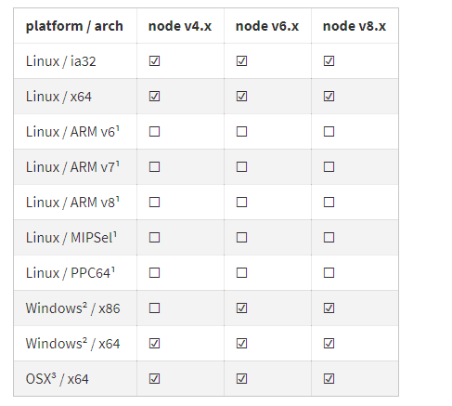

<https://github.com/adafruit/Adafruit-Fingerprint-Sensor-Library/tree/master/examples/fingerprint>

<https://social.msdn.microsoft.com/Forums/en-US/6a3c342a-0bf0-418f-835a-19491dcb0e2c/serial-port-com6-does-not-exist-?forum=vssmartdevicesvbcs>

*30-12-2017*

8:43 – 23:50

Gezocht hoe ik data kan sturen naar de Arduino via de serialport in node js

<https://www.npmjs.com/package/process>

<https://github.com/node-serialport/node-serialport/issues/937>

<https://github.com/node-serialport/node-serialport/blob/4.0.1/README.md>

<https://github.com/node-serialport/node-serialport#windows>

<https://github.com/node-serialport/node-serialport/blob/master/examples/mocking.js>

<https://stackoverflow.com/questions/38607979/node-js-path-to-serialport>

<https://github.com/node-serialport/node-serialport#usage>

<https://github.com/node-serialport/node-serialport/issues/817>

<https://msdn.microsoft.com/en-us/library/windows/desktop/aa363436(v=vs.85).aspx>

<https://stackoverflow.com/questions/36357472/accessing-virtual-serial-port-with-node-js-gives-either-error-or-no-open-event>

<https://stackoverflow.com/questions/4188782/set-dcb-fails-when-attempting-to-configure-com-port/4189646#4189646>

<https://stackoverflow.com/questions/35977468/nodejs-serialport-setcommstate>

<https://www.lifewire.com/how-to-fix-code-31-errors-2623184>

De data komt van de Arduino als buffer. Gezocht hoe ik deze data kan converteren naar een gewone data.

Data die ik krijg:

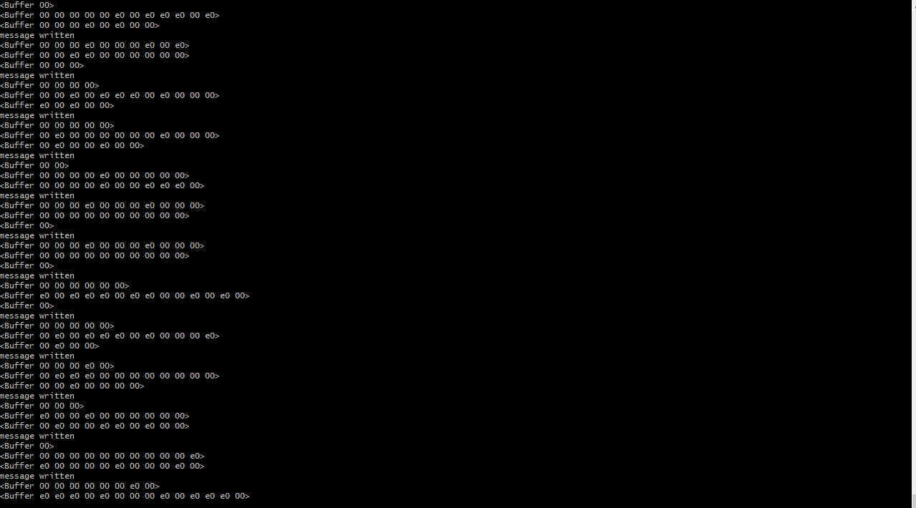

<https://stackoverflow.com/questions/44946377/how-to-convert-array-bytes-from-arduino-fingerprint-sensor-into-a-image>

[https://github.com/node-serialport/node-serialport#opening-a-port](https://github.com/node-serialport/node-serialport" \l "opening-a-port)

<https://github.com/node-serialport/node-serialport>

<https://github.com/adafruit/Adafruit-Fingerprint-Sensor-Library>

<https://forum.arduino.cc/index.php?topic=424107.0>

<https://github.com/EddyVerbruggen/nativescript-fingerprint-auth>

<https://stackoverflow.com/questions/44946377/how-to-convert-array-bytes-from-arduino-fingerprint-sensor-into-a-image>

<https://github.com/carlos8f/pemtools>

<https://forums.adafruit.com/viewtopic.php?f=25&t=126270>

<https://community.particle.io/t/fingerprint-reader-and-serial-pass-through/4688>

<https://learn.adafruit.com/adafruit-io/node-js>

<https://github.com/adafruit/adafruit-io-node>

<https://github.com/node-serialport/node-serialport>

<https://stackoverflow.com/questions/23540083/failed-to-open-stream-permission-denied-error-laravel/29292637>

<https://www.npmjs.com/package/express-fileupload>

<https://stackoverflow.com/questions/tagged/node-serialport>

<https://stackoverflow.com/questions/47129112/node-js-serialport-cannot-pass-variable-outside-serialport-list-function>

<https://itp.nyu.edu/physcomp/labs/labs-serial-communication/lab-serial-communication-with-node-js/>

<https://arduino.stackexchange.com/questions/42883/sending-string-over-serial-to-nodejs-app-why-does-it-get-chunked>

<http://www.meccanismocomplesso.org/en/arduino-tutorial-serial-data-actuator/>

<http://www.barryvandam.com/node-js-communicating-with-arduino/>

<https://www.youtube.com/watch?v=m-3XvNQko4s>

<http://arduino-er.blogspot.be/2014/09/nodejs-send-string-to-arduino-uno.html>

<https://itp.nyu.edu/physcomp/labs/labs-serial-communication/lab-serial-control-of-an-arduino/>

<http://thinkingonthinking.com/serial-communication-with-nodejs/>

<https://www.youtube.com/watch?v=SOxuwi0Chmo>

*31-12-2017*

9:00-20:00

Om de data van de node js server naar de browser te sturen gebruikte ik Socket.IO. Socket is een Javascript library om de data van de browser naar de server te sturen en omgekeerd in realtime.

<https://www.npmjs.com/package/serialport-v4>

<https://www.npmjs.com/package/socket.io>

<https://socket.io/>

<https://socket.io/demos/chat/>

<https://github.com/socketio/socket.io/blob/master/examples/chat/package.json>

<https://github.com/socketio/socket.io/tree/master/examples>

<https://www.youtube.com/watch?v=LNtmLapUSzw>

<https://www.youtube.com/watch?v=AhST3tTdmWk>

<https://www.youtube.com/watch?v=qg8nxeWnhsI>

<https://www.youtube.com/watch?v=-3Xg8x2ibeY>

<https://www.youtube.com/watch?v=rhagmAv35Kk>

<https://www.youtube.com/watch?v=jSxQma0MEJI>

<https://github.com/fbonetti/arduino_radar>

<https://gist.github.com/TotallyInformation/7115338>

<https://www.tigoe.com/pcomp/code/arduinowiring/1109/>

<https://stackoverflow.com/questions/30911185/javascript-reading-3-bytes-buffer-as-an-integer>

<https://nodejs.org/docs/latest/api/buffer.html#buffer_buf_readuintbe_offset_bytelength_noassert>

<https://stackoverflow.com/questions/8044543/how-can-i-store-an-integer-in-a-nodejs-buffer>

<https://nodejs.org/api/buffer.html#buffer_buf_writeuint8_value_offset_noassert>

<https://stackoverflow.com/questions/29089689/invalid-non-string-buffer-chunk-node-js>

<https://gist.github.com/ravenlp/5820493>

Hier probeer ik de data van node js naar de Arduino te sturen.

<https://gist.github.com/ladislas/6009827>

<https://forum.arduino.cc/index.php?topic=305128.0>

<https://github.com/sparkfun/Fingerprint_Scanner-TTL/tree/master/FPS_GT511C3/Examples/FPS_Enroll>

<https://channel9.msdn.com/Blogs/raw-tech/Arduino-talks-back-to-Nodejs-Drama-on-the-Serial-Port>

<https://github.com/node-serialport/node-serialport/tree/master/examples/socketio>

<http://forum.arduino.cc/index.php?topic=39873.0>

<http://danialk.github.io/blog/2014/04/12/arduino-and-nodejs-communication-with-serial-ports/>

<https://stackoverflow.com/questions/30696623/nodejs-send-data-to-arduino-using-serial>

<https://arduino.stackexchange.com/questions/18949/serial-communication-to-arduino-with-node-js>

<https://www.npmjs.com/package/arduino-serial>

<https://github.com/todbot/node-arduino-serial/tree/master/lib>

<https://stackoverflow.com/questions/12006417/node-js-server-that-accepts-post-requests>

<https://stackoverflow.com/questions/5710358/how-to-retrieve-post-query-parameters>

<https://stackoverflow.com/questions/11681407/how-to-communicate-through-serial-port-on-client-side-using-javascript>

<https://stackoverflow.com/questions/3310643/how-to-read-from-serial-port-in-a-webpage>

<https://itp.nyu.edu/physcomp/labs/labs-serial-communication/lab-serial-communication-with-node-js/>

<https://nodeolyk.wordpress.com/2011/11/10/node-js-how-to-store-integer-in-a-buffer/>

<https://stackoverflow.com/questions/5311334/what-is-the-purpose-of-node-js-module-exports-and-how-do-you-use-it>

<https://developer.mozilla.org/en-US/docs/Web/JavaScript/Reference/Global_Objects/Uint8Array>

<https://www.npmjs.com/package/buffer-layout>

<https://stackoverflow.com/questions/24588234/how-to-send-an-int-over-uint8-t-data>

<http://forum.arduino.cc/index.php?topic=126138.0>

<https://arduino.stackexchange.com/questions/3079/how-to-retrieve-the-data-type-of-a-variable>

<https://learn.sparkfun.com/tutorials/data-types-in-arduino>

<http://www.ladyada.net/learn/arduino/lesson4.html>

<https://stackoverflow.com/questions/45056303/how-can-i-convert-a-string-to-uint16-t-in-arduino>

<http://www.asciitohex.com/>

<http://www.tek-tips.com/viewthread.cfm?qid=1207107>

<http://forum.arduino.cc/index.php?topic=43719.0>

<https://www.arduino.cc/en/Tutorial/StringReplace>

<https://www.arduino.cc/reference/en/language/variables/data-types/string/functions/replace/>

<https://www.arduino.cc/reference/en/language/variables/data-types/unsignedint/>

<https://forum.arduino.cc/index.php?topic=253771.0>

Geprobeerd om de buffer naar gewone data te converteren met zoekresultaat Google “node js buffer binary data”

<https://stackoverflow.com/questions/10355856/how-to-append-binary-data-to-a-buffer-in-node-js>

zoekresultaat Google “convert decimal to binary online”

<https://www.rapidtables.com/convert/number/decimal-to-binary.html>

zoekresultaat Google “arduino parseint from string”

<https://www.arduino.cc/en/Tutorial/StringToIntExample>

zoekresultaat Google convert int to string Arduino

<https://stackoverflow.com/questions/7910339/how-to-convert-int-to-string-on-arduino>

zoekresultaat Google nodejs buffer to integer to serialport

<https://github.com/DeekyJay/serialport>

<https://stackoverflow.com/questions/36347553/javascript-serialport-cant-output-numbers-just-ascii>

zoekresultaat Google serial.available() meaning

<https://www.arduino.cc/en/Serial/Available>

zoekresultaat while (! Serial.available());

<http://forum.arduino.cc/index.php?topic=41809.0>

<https://www.arduino.cc/reference/en/language/structure/boolean-operators/logicaland/>

zoekresultaat arduino int to uint8\_t

<https://gathering.tweakers.net/forum/list_messages/1699081>

*1-1-2017*

12:00 -23:00

<https://www.youtube.com/watch?v=km3g-Idg6OQ&feature=youtu.be>

zoekresultaat nodejs buffer ascii nimber

<https://stackoverflow.com/questions/47089018/nodejs-buffer-tostring-changed-original-buffer>

<https://stackoverflow.com/questions/42623883/how-to-convert-node-js-buffer-to-integer-in-the-client-side>

zoekresultaat nodejs buffer ascii number

zoekresultaat nodejs serial port buffer number

<https://github.com/node-serialport/node-serialport/issues/1213>

<https://github.com/Stuk/jszip/issues/458>

Error Invalid non-string/buffer chunk

<https://datastax-oss.atlassian.net/browse/NODEJS-372>

<https://github.com/node-serialport/node-serialport/issues/1404>

Gezocht hoe ik de data kan lezen die van de Arduino komt

<https://www.arduino.cc/en/Serial/Read>

<https://www.arduino.cc/en/Reference/StreamRead>

<https://forum.arduino.cc/index.php?topic=102240.0>

<http://www.instructables.com/id/Arduino-Function-Serialread-And-SerialreadString/>

zoekresultaat: how to send byte array in node js

<https://stackoverflow.com/questions/20979800/send-byte-array-in-node-js-to-server>

[https://nodejs.org/api/stream.html#stream\_writable\_write\_chunk\_encoding\_callback](https://nodejs.org/api/stream.html" \l "stream_writable_write_chunk_encoding_callback)

<https://stackoverflow.com/questions/18327807/node-js-serialport-trying-to-write-and-i-just-cant-figure-it-out>

Zoekresultaat Read strings line by line from Buffer in node js

<https://stackoverflow.com/questions/36896841/read-strings-line-by-line-from-buffer-instance-in-node-js-module>

<https://github.com/nickewing/line-reader>

<http://www.brainboxes.com/faq/items/how-do-i-control-a-serial-port-using-php>

[http://be2.php.net/manual/en/install.windows.legacy.index.php#install.windows.legacy.building](http://be2.php.net/manual/en/install.windows.legacy.index.php" \l "install.windows.legacy.building)

<https://stackoverflow.com/questions/44467202/php-serial-com-port-sent-and-receive-data>

<https://stackoverflow.com/questions/44439255/php-trying-to-read-data-from-serial-com-port-windows>

Error: php serialport Unable to open the device

<https://github.com/Xowap/PHP-Serial/issues/9>

<https://code.google.com/archive/p/php-serial/issues/7>

<https://github.com/matak/php-serial/issues/7>

<http://www.instructables.com/id/Control-Arduino-using-PHP/>

<https://stackoverflow.com/questions/27854289/unable-to-open-com-port-using-phpserial-with-xampp>

<https://support.microsoft.com/en-us/help/115831/howto-specify-serial-ports-larger-than-com9>

zoekresultaat serial port node js parser not send data to Arduino

<https://www.arduinoslovakia.eu/blog/2017/5/komunikacia-medzi-arduinom-a-nodejs-pomocou-serioveho-portu?lang=en>

<https://www.raspberrypi.org/forums/viewtopic.php?t=151184>

<http://chipkit.net/forum/viewtopic.php?t=3731>

<https://www.npmjs.com/package/jspmserialport>

<https://github.com/node-serialport/node-serialport/blob/4.0.1/README.md>

Gezocht hoe ik de buffer lijn per lijn kan lezen:

<https://www.npmjs.com/package/line-by-line>

<https://github.com/jahewson/node-byline>

zoekresultaat node js convert byte to string

<https://stackoverflow.com/questions/20281986/how-to-convert-an-array-of-bytes-into-string-with-node-js>

zoekresultaat npm randbytes

<https://www.npmjs.com/package/randbytes>

<https://github.com/cujojs/when>

<https://stackoverflow.com/questions/47089230/how-to-convert-buffer-to-stream-in-nodejs>

<https://stackoverflow.com/questions/45891242/how-to-pass-a-buffer-as-argument-of-fs-createreadstream/45891702#45891702>

<https://stackoverflow.com/questions/16038705/how-to-wrap-a-buffer-as-a-stream2-readable-stream>

<https://github.com/gagle/Node-Streamifier>

<https://github.com/gagle/node-streamifier/blob/master/lib/index.js>

<https://www.npmjs.com/package/stream>

<https://github.com/gagle/node-streamifier/tree/master/lib>

Zoekresulaat: Buffer to Json in nodejs

<https://hackernoon.com/https-medium-com-amanhimself-converting-a-buffer-to-json-and-utf8-strings-in-nodejs-2150b1e3de57>

zoekresultaat StringDecoder

<https://nodejs.org/api/buffer.html#buffer_class_buffer>

<https://nodejs.org/api/string_decoder.html>

Gezocht hoe ik een buffer kan decoderen in node js:

<https://hackernoon.com/https-medium-com-amanhimself-converting-a-buffer-to-json-and-utf8-strings-in-nodejs-2150b1e3de57>

<https://stackoverflow.com/questions/16038705/how-to-wrap-a-buffer-as-a-stream2-readable-stream>

2-1-2018

Zoekresultaat node.js convert byte array to string

<https://bitcoin.stackexchange.com/questions/52727/byte-array-to-hexadecimal-and-back-again-in-javascript>

<https://stackoverflow.com/questions/34309988/byte-array-to-hex-string-conversion-in-javascript>

<https://blog.ipsumdomus.com/converting-buffer-to-object-in-node-js-d90ec0a88f9b>

zoekresultaat nodejs serialport parser

<https://stackoverflow.com/questions/44820013/custom-parser-for-node-serialport>

zoekresultaat nodejs serialport parser on data coming

<https://stackoverflow.com/questions/379906/parse-string-to-float-or-int?rq=1>

<https://stackoverflow.com/questions/47128242/node-js-serialport-read-data-parsing-issues>

<https://stackoverflow.com/questions/17603304/read-serialport-with-node-serial?rq=1>

<https://stackoverflow.com/questions/44820013/custom-parser-for-node-serialport>

zoekresultaat port.pipe(new Readline(data)).toString()

<https://github.com/node-serialport/node-serialport/issues/1298>

[https://nodejs.org/api/buffer.html#buffer\_buf\_tojson](https://nodejs.org/api/buffer.html" \l "buffer_buf_tojson)

zoekresultaat nodejs hex to string

<https://stackoverflow.com/questions/22901240/how-to-convert-a-hex-string-to-a-byte-and-a-byte-to-a-hex-string-in-javascript>

<https://stackoverflow.com/questions/39080649/reading-data-from-nodejs-serialport>

<https://stackoverflow.com/questions/tagged/serial-port>

<https://stackoverflow.com/questions/47129112/node-js-serialport-cannot-pass-variable-outside-serialport-list-function>

<https://stackoverflow.com/questions/47128242/node-js-serialport-read-data-parsing-issues>

<https://stackoverflow.com/questions/47111023/get-return-variable-from-serialport>

<https://stackoverflow.com/questions/46814962/node-js-serialport6-0-0-opening-port-and-closing-it-automatically>

<https://stackoverflow.com/questions/46363769/node-js-serialport-5-wrong-buffer>

<https://stackoverflow.com/questions/tagged/node-serialport>

<https://stackoverflow.com/questions/46034383/cant-read-data-from-arduino-uno-with-serialport-node-js-library>

<https://stackoverflow.com/questions/tagged/node-serialport?page=2&sort=newest&pagesize=15>

<https://stackoverflow.com/questions/44946377/how-to-convert-array-bytes-from-arduino-fingerprint-sensor-into-a-image>

<http://forum.arduino.cc/index.php?topic=103511.0>

zoekresultaat arduino convert char to int

<https://forum.arduino.cc/index.php?topic=456928.0>

<https://www.arduino.cc/en/Serial/SetTimeout>

zoekresultaat arduino settimeout example

<http://forum.arduino.cc/index.php?topic=208103.0>

zoekresultaat ajax send xml to server

<https://stackoverflow.com/questions/7345107/jquery-ajax-post-xml-structure-filter-chain>

zoekresultaat jquery ajax send json

<https://gabrieleromanato.name/jquery-sending-json-data-to-php-with-ajax>

<http://api.jquery.com/jquery.ajax/>

zoekresultaat nodejs request ajax

<https://stackoverflow.com/questions/15945118/detecting-ajax-requests-on-nodejs-with-express/15945578>

zoekresultaat nodejs request ajax express

<https://stackoverflow.com/questions/41952913/node-js-express-how-can-i-know-if-a-request-is-an-ajax-request>

3-1-2018

<https://stackoverflow.com/questions/48077960/how-to-convert-incoming-buffer-data-from-serial-port-to-nodejs>

zoekresultaat nodejs buffer int to serial port

<https://www.npmjs.com/package/numeric-buffer>

zoekresultaat Adafruit\_Fingerprint nodejs

<https://github.com/adafruit/Adafruit-Fingerprint-Sensor-Library/blob/master/examples/show_fingerprint_templates/show_fingerprint_templates.ino>

<http://educ8s.tv/arduino-fingerprint-sensor-module-tutorial/>

Oplossing gevonden om de data van de buffer te lezen:

https://stackoverflow.com/questions/42730976/read-node-serialport-stream-line-by-line

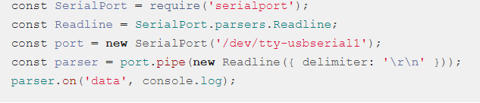

<https://github.com/adafruit/Adafruit-Fingerprint-Sensor-Library>

<https://www.youtube.com/watch?v=KA7ZqTPvInw>

<https://forum.arduino.cc/index.php?topic=439572.0>

zoekresultaat adafruit fingerprint get image

<https://www.youtube.com/watch?v=KA7ZqTPvInw&t=9s>

zoekresultaat node js create session

<https://www.npmjs.com/package/express-session>

<https://stackoverflow.com/questions/5765777/nodejs-how-to-create-and-read-session-with-express>

<https://stormpath.com/blog/everything-you-ever-wanted-to-know-about-node-dot-js-sessions>

<https://codeforgeek.com/2014/09/manage-session-using-node-js-express-4/>

<https://github.com/expressjs/session>

<https://codeforgeek.com/category/nodejs/express/>

<https://codeforgeek.com/category/nodejs/>

<https://medium.com/of-all-things-tech-progress/starting-with-authentication-a-tutorial-with-node-js-and-mongodb-25d524ca0359>

<https://nodewebapps.com/2017/06/18/how-do-nodejs-sessions-work/>

<https://www.codementor.io/emjay/how-to-build-a-simple-session-based-authentication-system-with-nodejs-from-scratch-6vn67mcy3>

zoekresultaat nodejs create cookie

<https://www.npmjs.com/package/cookie>

<https://stackoverflow.com/questions/3393854/get-and-set-a-single-cookie-with-node-js-http-server>

zoekresultaat cookieparser npm

<https://www.npmjs.com/package/cookie-parser>

<https://github.com/senchalabs/connect#middleware>

zoekresultaat node js express middleware

<http://expressjs.com/en/guide/using-middleware.html>

zoekresultaat nodejs crypto md5

<https://www.npmjs.com/package/crypto-md5>

zoekresultaat nodejs mysql

<https://www.w3schools.com/nodejs/nodejs_mysql.asp>

zoekresultaat mysql create db command

<https://dev.mysql.com/doc/refman/5.7/en/creating-database.html>

# zoekresultaat Node.js MySQL Insert Into

<https://www.w3schools.com/nodejs/nodejs_mysql_insert.asp>

<https://www.w3schools.com/nodejs/nodejs_mysql_select.asp>

zoekresultaat node js localstorage

<https://www.npmjs.com/package/node-localstorage>

<https://github.com/lmaccherone/node-localstorage>

<https://github.com/lmaccherone/node-localstorage/issues/30>

<https://github.com/lmaccherone/node-localstorage/issues>

<https://github.com/lmaccherone/node-localstorage/issues/29>

zoekresultaat node.js get parameters express

<http://stackabuse.com/get-query-strings-and-parameters-in-express-js/>

<https://stackoverflow.com/questions/43560557/query-parameters-in-express>

<https://stackoverflow.com/questions/41805230/how-to-set-cookie-on-a-browser-using-node-js-included-api>

<https://www.npmjs.com/package/cookies>

<https://github.com/aviddiviner/Socket.IO-sessions>

<https://stackoverflow.com/questions/4641053/socket-io-and-session>

zoekresultaat nodejs create session socket

<https://gist.github.com/6174/6255126>

<https://botleg.com/stories/using-your-sessions-with-socketio/>

<https://www.npmjs.com/package/express-session>